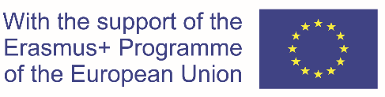

Erasmus Mundus Joint Master Degrees – Main mobility achievements and results

Project title:

Total number of enrolled students (all intakes, including EMJMD scholarship holders and non-scholarship holders)

Total number of EMJMD scholarship holders from Erasmus+ Partner countries (all intakes)

Total number of EMJMD scholarship holders from Erasmus+ Programme countries (all intakes)

Type of diploma awarded:
☐ Joint diploma provided by all partner higher education institutions
☐ Joint diploma provided by the higher education institutions attended by each student
☐ Multiple / double diploma
☐ Combination of joint and national diplomas

Joint diploma supplement :
☐ Yes
☐ No

Percentage of graduates in employment or study 12 months after graduation:

