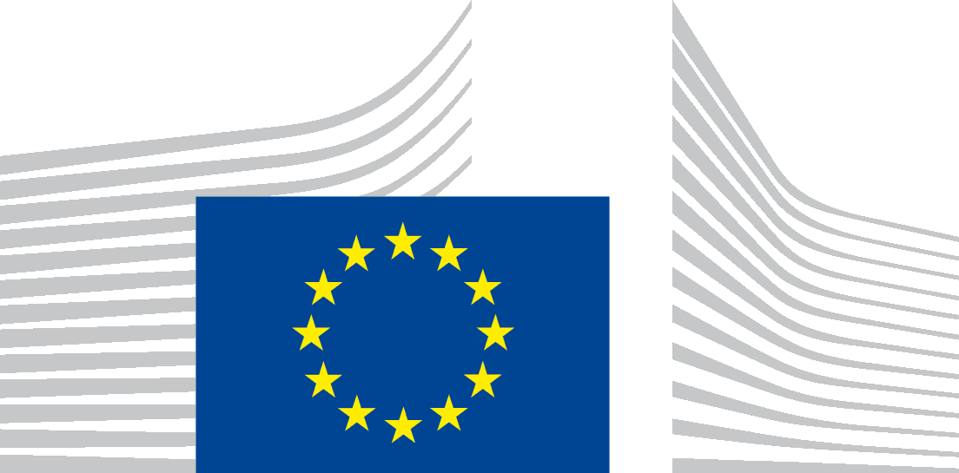 | EUROPEAN EDUCATION AND CULTURE  EXECUTIVE AGENCY (EACEA)
Brussels
EACEA.B3

Info-session CERV-2023-CITIZENS-TOWN-TT
on 16th of May 2024 and further communication

Data Protection Notice

The European Education, and Culture Executive Agency ("EACEA") is committed to preserving your privacy. All personal data are dealt with in accordance with Regulation (EU) No 2018/1725 on the protection of personal data by the Union institutions, bodies, offices and agencies ("the data protection regulation").

On 16th of May 2024, EACEA is organising the info-session for potential applicants under the CERV-2024-CITIZENS-TOWN-TT through Webex. The following Data Protection Notice outlines the policies by which EACEA collects, manages and uses the personal data of the concerned individuals taking part in the on line event.
- Who is responsible for processing your personal data (data controller)?
The controller is the European Education and Culture Executive Agency, BE-1049 Brussels. The person designated as being in charge of the processing operation is the Head of Unit EACEA B.3 - Citizens and EU Values

Email: EACEA-CERV@ec.europa.eu
- Which personal data are processed?
Mandatory data for the event organisation: your contact details, i.e. title, first name, last name, and email address of participants, position, voice and image of the speakers
Optional data:
- Images and voice of the participants might be shown during the event. The event will audio and video recorded, and images and video recordings of the event may be published on EACEA’s and / or the European Commission’s intranet and external websites (such as https://www.eacea.ec.europa.eu/).

Participants are encouraged to provide, to the extent possible, anonymised data to register to the event (corporate email address without name e.g. contact@companyname.com).
- For which purpose do we process your data?
Organising and managing the event: the primary purpose of the collection of personal data is for the organisation of the given event, in particular for processing registration requests and sending appropriate information to participants such as web-links of the event as well as a feedback form.
- Recording: The event will be audio and video recorded for internal control and communication purposes. We will record speakers’ presentations and their answers to participants’ questions. When asking questions, participants can either use video and/or audio or webex chat. If they choose to ask questions using video and/or audio, participants will be recorded accordingly. Participants are invited to switch off their micro and camera if they do not want to appear in the recording.

- Publication: Images and video recordings of the participants to the event (including speakers/moderators) may be published on EACEA’s and / or the European Commission’s intranet and external websites and the images in the recording can be used by the EACEA and the European Commission for communication purposes.

- In the purpose of searching new partners, participants can give their specific consents to share their personal data (names, functions, addresses and emails) with other participants.

- Who has access to your personal data and to whom is it disclosed?
Access to your personal data may be given on a need-to know basis to the following recipients:
- EACEA: Staff members of the unit of the controller, Director, and Heads of Department.
- European Commission: relevant DGs in particular the Directorate-General for Justice and Consumers (DG JUST).
- Webex will process your data for the purpose of organising and managing the event.
- General public: video and audio recording including participants’ personal data (face, voice, presenters’ contribution) may be published on EACEA’s and / or the European Commission’s intranet and external websites. In addition, for participants which will give their specific consents, personal data (names, functions, addresses and emails) will be shared between participants in order to create new partnerships for applications.

In case of control or dispute, the bodies charged with a monitoring or inspection task in application of Union law (e.g. Internal Audit Service, European Commission, OLAF, EU Courts etc.).
Use of a video conferencing tool/third party tool: please note that the event will be organised using Webex, which has a contract with the European Commission. Your personal data used for your participation to the event will also be processed by this tool, in accordance with its privacy policy which can be found here: https://ec.europa.eu/dpo-register/detail/DPR-EC-04966.

Please note that in order to deliver the service, Webex might transfer your personal data outside the EU in accordance with its privacy policy (mentioned above). Such transfer will be made based on standard contractual clauses as part of a contract between the service provider and the European Commission. You can obtain more information on it by contacting the data controller at the above-mentioned email address.

- How long do we keep your personal data?
Mandatory data relating to the Registration process of the event will be kept for the 12 months after the closure of the event planned for the 16/05/2024. However, we may keep information identifying you for a longer period for historical, statistical, or scientific purposes with the appropriate safeguards in place.
Video and audio recording will be published on the on EACEA’s and / or the European Commission’s intranet and external websites (such as https://www.eacea.ec.europa.eu/) for a maximum of 12 months after the event.

- What are your rights concerning your personal data and how can you exercise them?
Under the provisions of the data protection regulation, you have the right to:
- Request to access the personal data EACEA holds about you;
- Request a rectification of your personal data where necessary;
- Request the erasure of your personal data;
- Request the restriction of the processing of your personal data;
For the processing of your personal data which is based on public interest under of Article 5(1)(a) of the data protection regulation, please note that you have the right to object to processing of your personal data on grounds relating to your particular situation under the provisions of Article 23 of the data protection regulation.
For the processing of your personal data which is based on your consent under Article 5(1)(d), please note that you can withdraw it at any time, and this will have effect from the moment of your retraction. The processing based on your consent before its withdrawal will remain lawful.
You should also be informed that by virtue of Article 25 of the data protection regulation and of the Internal Rules laid down under Decision of the Steering Committee on internal rules concerning restrictions of certain rights of data subjects in relation to the processing of personal data in the framework of activities carried out by the European Education and Culture Executive Agency dated 22 October 2020 (published on the Official Journal: https://eur-lex.europa.eu/legal-content/EN/TXT/?uri=CELEX:32021Q0317%2801%29), one or several of these rights may be restricted for a temporary period of time inter alia on the grounds of prevention, investigation, detection and prosecution of criminal offences.
- Your right to have recourse in case of conflict on any personal data issue
In case of conflict on any personal data protection issue you can address yourself to the Controller at the above mentioned contact details.
You can also contact the Data Protection Officer of EACEA at the following email address: eacea-data-protection@ec.europa.eu.
You may lodge a complaint with the European Data Protection Supervisor at any time: http://www.edps.europa.eu.
- On which legal basis are we processing your personal data?
The Processing of your personal data is based on the following legal basis:
Art. 5(1)(a) processing is necessary for the performance of a task carried out in the public interest or in the exercise of official authority vested in the Union institution or body (to be laid down in Union Law)
The applicable legal basis under Art. 5(1)(a) are:
- The Commission Implementing Decision 2021/173 establishing the European Education and Culture Executive Agency;
- The Commission Decision C(2021)951 and its annexes delegating powers to EACEA for the management of programmes in the MFF 2021-2027.
- Regulation (EU) 2021/692 of the European Parliament and of the Council of 28 April 2021 establishing the Citizens, Equality, Rights and Values Programme and repealing Regulation (EU) No 1381/2013 of the European Parliament and of the Council and Council Regulation (EU) No 390/2014
For collecting and processing your data for the purpose of organising and managing the event. Provision and processing of these personal data is mandatory to attend to the event.
For processing of your personal data using the above mentioned third party tool(s) used to organise the event
For recording and publication of the recording (for speakers)

Art. 5(1)(d) the data subject has given consent to the processing of his or her personal data for one or more specific purposes:
- Audio and Video recording of the event, and publication on EACEA’s and / or the European Commission’s intranet and external websites (such as https://www.eacea.ec.europa.eu/).

Participants who do not want to be recorded and appear on the recording can decide to keep their camera and micro off and watch the recording once published. They acknowledge that in case they voluntarily choose to turn on their microphone and camera and to actively participate in the discussions, their image and voice will be recorded during the event, and that this recording will be published.

Regulation (EU) 2018/1725 of the European Parliament and of the Council of 23 October 2018 on the protection of natural persons with regard to the processing of personal data by the Union institutions, bodies, offices and agencies and on the free movement of such data, and repealing Regulation (EC) No 45/2001 and Decision No 1247/2002/EC Text with EEA relevance, OJ L 295, 21.11.2018, p. 39.
Regulation (EU) 2021/692 of the European Parliament and of the Council of 28 April 2021 establishing the Citizens, Equality, Rights and Values Programme (OJ L 156, 5.5.2021, p. 1). Commission Implementing Decision C(2021) 2583 final of 19/04/2021 on the financing of the Citizens, Equality, Rights and Values programme and the adoption of the multiannual work programme for 2021-2022

