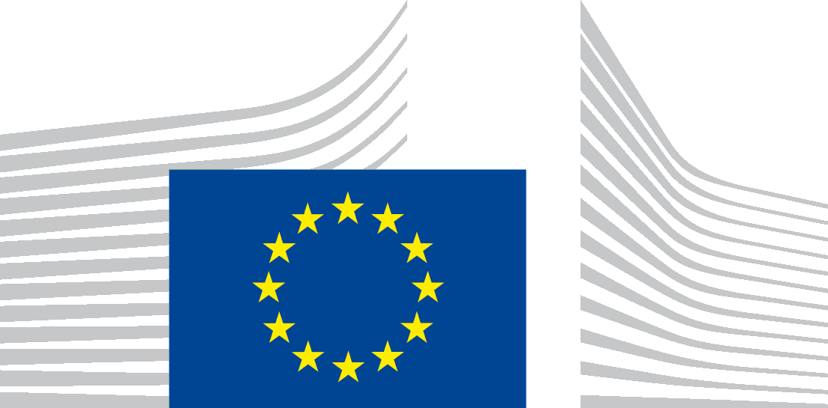 | EUROPEAN EDUCATION AND CULTURE  EXECUTIVE AGENCY (EACEA)
Brussels, 9/12/2024 ​
EACEA.B3

CERV Civil Dialogue – Online Info Session on the Call for Proposals Network of Towns (CERV-2025-CITIZENS-TOWN-NT) on 6 February 2025

Data Protection Notice

The European Education, and Culture Executive Agency ("EACEA") is committed to preserving your privacy. All personal data are dealt with in accordance with Regulation (EU) No 2018/1725 on the protection of personal data by the Union institutions, bodies, offices and agencies ("the data protection regulation").

On the 6th February 2025, EACEA is organising the CERV– Online Info Session on the Call for Proposals Networks of Town (CERV-2025-CITIZENS-TOWN-NT) through WEBEX. The following Data Protection Notice outlines the policies by which EACEA collects, manages, and uses the personal data of the concerned individuals taking part in the info day meeting.
- Who is responsible for processing your personal data (data controller)?
The controller is the European Education and Culture Executive Agency, BE-1049 Brussels.
The person designated as being in charge of the processing operation is the Head of Unit EACEA B.3 - Citizens and EU Values.

Email: EACEA-CERV@ec.europa.eu
- Which personal data are processed?

In order to carry out the processing operation, the following data may be processed:
- Names, surnames and images of participants appearing on the screen (i.e. when they speak, ‘interactions among participants, contact details …);
- Voices and meeting recording of the speakers .

If participants do not want their names to appear in the recording, they are invited to connect to Webex with the name of their organisation and to close their camera.
- For which purpose do we process your data?

Your personal data are collected and used to organise and manage the online info-session for the Call for Proposals managed by EACEA under the Citizens, Equality, Rights and Values (CERV) Programme.

The online info-session will be divided in different parts: presentations to be given by EACEA and DG Justice staff and parts where the participants will have the opportunity to ask questions. The parts with the presentations will be recorded. The Q&A sessions will not be recorded. The recordings will be then published on the EACEA’s website on the event webpage, so that interested applicants who could not attend the info-session can watch them later.
Use of the external voting device of SLIDO to collect opinions, questions and reply to polls during said event will be encouraged, in order to have more interaction.
Your personal data will not be used for an automated decision-making including profiling.
- Who has access to your personal data and to whom is it disclosed?
Access to your personal data may be given on a need-to know basis to the following recipients:
- EACEA: authorised staff responsible for carrying out this processing operation. Such staff abide by statutory confidentiality obligations.
- Authorised staff of the European Commission: relevant DGs in particular:
  - the Directorate-General for Justice and Consumers (DG JUST),
  - the Directorate-General for Digital Services (DG DIGIT) acting as processor for EACEA and its contractor (CISCO) for the use of WEBEX/ web conference service (see below Privacy Statement for WEBEX).
Public access for data (speakers’ presentation) published on the EACEA’s website on the event webpage.
In the context of WEBEX your data may be transferred to the UK and the U.S. in certain circumstances as specified in their Privacy Statement: https://ec.europa.eu/dpo-register/detail/DPR-EC-05006 . This transfer may be based on Standard Contractual Clauses or on the Adequacy Decisions adopted by the European Commission with the U.S. and with the UK respectively.
As SLIDO was acquired by CISCO Systems, Inc., personal data may be transferred to CISCO. SLIDO will process your data in line with the related privacy statement: see https://ec.europa.eu/dpo-register/detail/DPR-EC-06687. Participants, who wish to use the on-line audience interaction tool SLIDO and who are not willing to share their personal data with the selected tool, can simply reply anonymously.
In addition, data may be disclosed to public authorities in accordance with Union and Member State law such as the European Court of Justice, the relevant national judge as well as the lawyers and the agents of the parties in case of legal proceedings, the Investigation and Disciplinary Office of the European Commission (IDOC), the competent Appointing Authority in case of a request or a complaint lodged under Articles 90 of the Staff Regulations, the European Anti-Fraud Office (OLAF), the Internal Audit Service of the Commission (IAS), the Court of Auditors, the European Ombudsman, the European Data Protection Supervisor (EDPS) and the European Public Prosecutor’s Office (EPPO).
- How long do we keep your personal data?
Data relating to this event will be kept maximum for the 12 months after the closure of the event planned for the 6/02/25 and will be deleted afterwards.
- What are your rights concerning your personal data and how can you exercise them?
Under the provisions of the data protection regulation, you have the right to:
- Request to access the personal data EACEA holds about you;
- Request a rectification of your personal data where necessary;
- Request the erasure of your personal data;
- Request the restriction of the processing of your personal data;
For the processing of your personal data which is based on public interest under of Article 5(1)(a) of the data protection regulation, please note that you have the right to object to processing of your personal data on grounds relating to your particular situation under the provisions of Article 23 of the data protection regulation.
You should also be informed that by virtue of Article 25 of the data protection regulation and of the Internal Rules laid down under Decision of the Steering Committee on internal rules concerning restrictions of certain rights of data subjects in relation to the processing of personal data in the framework of activities carried out by the European Education and Culture Executive Agency dated 22 October 2020 (published on the Official Journal: https://eur-lex.europa.eu/legal-content/EN/TXT/?uri=CELEX:32021Q0317%2801%29), one or several of these rights may be restricted for a temporary period of time inter alia on the grounds of prevention, investigation, detection and prosecution of criminal offences.
- Your right to have recourse in case of conflict on any personal data issue
If you have questions or wish to exercise your rights under the data protection regulation or if you want or to submit a complaint regarding the processing of your personal data, you can address yourself to the Controller at the above-mentioned contact details.
You can also contact the Data Protection Officer of EACEA at the following email address: eacea-data-protection@ec.europa.eu.
You may lodge a complaint with the European Data Protection Supervisor at any time: http://www.edps.europa.eu.
- On which legal basis are we processing your personal data?
The Processing of your personal data is based on the following legal basis:
Art. 5(1)(a) of the data protection regulation: processing is necessary for the performance of a task carried out in the public interest or in the exercise of official authority vested in the Union institution or body (laid down in Union Law):
- For collecting and processing your data for the purpose of organising and managing the event. Provision and processing of these personal data is mandatory to attend to the event.
The applicable legal basis under this article) are:
- The Commission Implementing Decision 2021/173 establishing the European Education and Culture Executive Agency;
- The Commission Decision C(2021)951 and its annexes delegating powers to EACEA for the management of programmes in the MFF 2021-2027.
- Regulation (EU) 2021/692 of the European Parliament and of the Council of 28 April 2021 establishing the Citizens, Equality, Rights and Values Programme and repealing Regulation (EU) No 1381/2013 of the European Parliament and of the Council and Council Regulation (EU) No 390/2014.

- How do we protect and safeguard your personal data?

Relevant organisational and technical measures are taken by EACEA to ensure the security of your personal data.
Technical measures include appropriate actions to address online security, risk of data loss, alteration of data or unauthorised access, taking into consideration the risk presented by the processing and the nature of the personal data being processed.
Organisational measures include restricting access to the personal data solely to authorised persons with a legitimate need to know for the purposes of this processing operation. Access to your data is done via authentication system on an individual basis through user-ID and password. Your data resides either on the cloud of EACEA’s contractor or on the servers of the European Commission, which abide by strict security measures implemented by the European Commission (DG DIGIT) to protect the security and integrity of the relevant electronic assets. EACEA is also bound by Commission Decision 2017/46 of 10/1/17 on the security of communications & information systems in the EC.
EC’s contractors are bound by a specific contractual clause for any processing operations of your data on behalf of the Commission, and by the confidentiality obligations deriving from the transposition of the General Data Protection Regulation in the EU Member States (‘GDPR’ Regulation (EU) 2016/679.

Regulation (EU) 2018/1725 of the European Parliament and of the Council of 23 October 2018 on the protection of natural persons with regard to the processing of personal data by the Union institutions, bodies, offices and agencies and on the free movement of such data, and repealing Regulation (EC) No 45/2001 and Decision No 1247/2002/EC Text with EEA relevance, OJ L 295, 21.11.2018, p. 39.
Regulation (EU) 2021/692 of the European Parliament and of the Council of 28 April 2021 establishing the Citizens, Equality, Rights and Values Programme (OJ L 156, 5.5.2021, p. 1). Commission Implementing Decision C/2022/8588 final of 01/12/2022 concerning the adoption of the work programme for 2023-2024 and the financing decision for the implementation of the Citizens, Equality, Rights and Values Programme.

