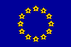

Ref. Ares(2025)342185 - 16/01/2025

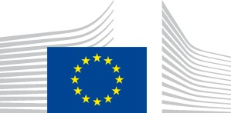EUROPEAN COMMISSION

MEETING MINUTES

|  |  |
| --- | --- |
| **Date:** | *Insert the date of the meeting, e.g. 9 May 2025* |
| **Location:** | *Insert the location of the meeting, e.g. Brussels, Videoconference* |
| **Name(s) and function(s) of the Commission representative(s):** | *Insert the full name(s) and function(s) of the Commissioner(s), Cabinet member(s) and/or Commission staff holding management functions present at the meeting* |
| **Name(s) of the interest representative(s):** | *Insert the full name(s) of the interest representative(s) met, as provided in the Transparency Register and to be selected in ATMOS (No personal data of the individuals representing the interest representative(s) concerned)* |
| **Subject matter:** | *Insert a brief description of the topic(s) discussed, e.g. Exchange of views on the reform of the Common Agriculture Policy, Discussion on the future Multiannual Financial Framework* |
| **Main points raised and positions expressed:** | *Summarise the main points raised and positions expressed by all participating parties, preferably in bullet points* |
| **Conclusions:** | *Summarise the conclusions from the meeting, if applicable (if not, insert ‘N/A’)* |